What is GDPR?
The General Data Protection Regulation (GDPR) is a Regulation that will replace the current Data Protection Act 1998 on 25th May 2018. The Regulation is intended to strengthen and unify data protection for individuals within the European Union.
Why does it matter?
Changes under GDPR are aimed at moving organisations away from a tick box compliance attitude to security and privacy of personal data, and instead moves towards an organisational approach to managing the lifecycle of personal data, from its collection, use, processing, retention and destruction.
What does it mean for Schools?
to the term GDPR seems to be everywhere at the moment, as it is such a large topic of conversation. Practically it will bring some dramatic changes related to data security and privacy. Schools, as individual Data Controllers, are responsible for compliance with the Regulation and need to consider how they comply prior to the Regulation coming into force.
What are the key changes?
- Updated definition of what is classed as personal data
- Greater enforcement powers provided to the Information Commissioner to fine Data Controllers up to €20,000,000 for significant data security breaches or failure to comply with the Regulation
- Mandatory requirement for a School to have, or be contracted with, a Data Protection Officer
- Enhanced rights for individuals under their Rights of access, including removal of statutory fees for subject access requests (access to their personal data) and new rights to rectification and erasure
- New legal liabilities where a Data Controller contracts with a third party provider (Data Processor) to provide services through which personal data is processed
- Mandatory requirements to complete Data Protection Impact Assessments before a Data Controller introduces a change to processing of personal data
- Mandatory reporting of most data security incidents to the Information Commissioner’s Office
What support is available?
For Schools that have signed up with the Information Governance Service Level Agreement, you will already have had the opportunity for Teachers and Governors to attend a number of seminars conducted by the Council’s Information Governance Team and Information Commissioner’s Officer in Wales.
These seminars have outlined the key changes, their impact on Schools, and given some pointers towards what you need to consider.
The Council’s Information Governance Team will continue to provide templates and guidance to Schools over the coming months, both pre and post the Regulation coming into force including:
- Template Information Asset Registers (IAR) and guidance for completing a IAR, together with guidance on what you should do with this information to work towards compliance
- Updated template Data Protection Policies for the School to adopt
- Guidance on Fair Processing Disclaimers and access to the Council’s and Welsh Government’s updated Privacy Notices which pupils and parents should be made aware of
- Access to online e-learning training on GDPR for Schools to ensure that staff are aware of the Regulations and what it means to you
- Guidance on the support which where a School may need the Information Governance Team to act as the contracted Data Protection Officer where a compliant or data security incident occurs (available from 25th May 2018).
What should you do now?
The most important task is for a School to compile an Information Asset Register (IAR). This will enable you to know what personal data you hold, why you hold it, and enables you to understand what controls and individual rights under GDPR might apply to the personal data held.

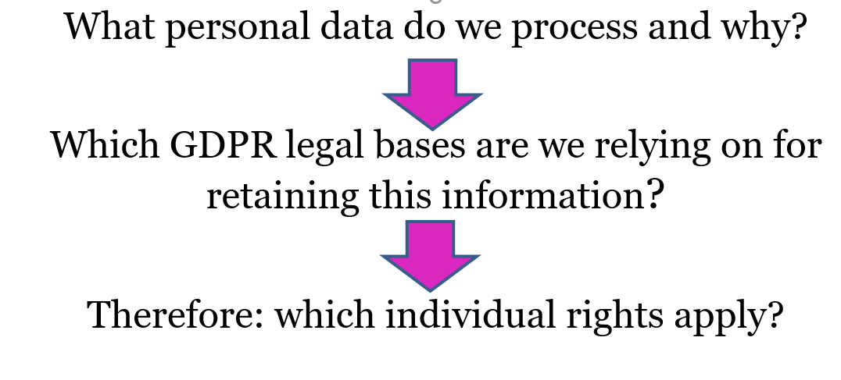
Look out for further guidance and support from the Information Governance Team over the coming weeks and direct your queries to the Information Governance Schools Support Service by email: SchoolsInformationManagement@cardiff.gov.uk

