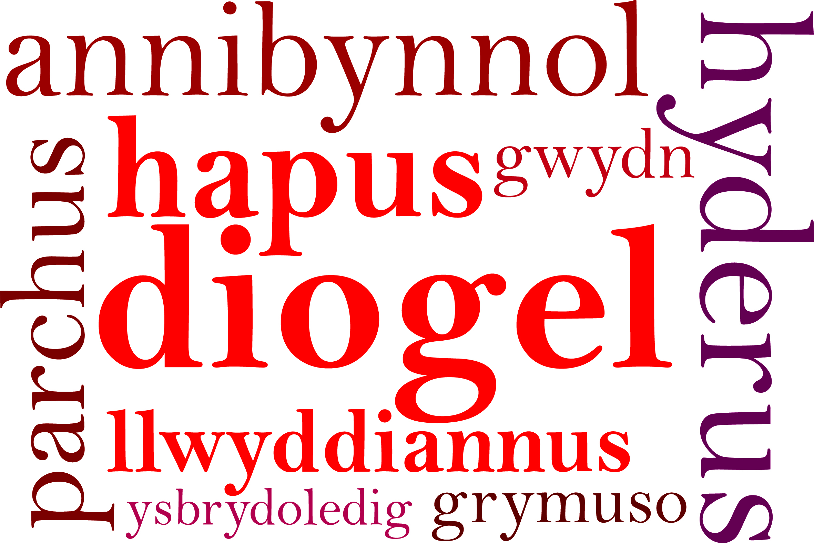



Dear Parents/Carers 21st September 2018

We are pleased to inform you that we are starting netball club for children in year 6. The club will commence on Tuesday 25th September 2018.
.
The club will take place on Tuesdays from 3:15 p.m. to 4:15 p.m.

If you would like your child to attend this club, please fill in the proforma at the bottom of this letter and return it to us as soon as possible. Please provide a contact number in case the club is cancelled due to inclement weather. Please also add netball club on Schoop .

Children will need to wear suitable laced trainers and games kit.

Children in the after school club will need to be collected from the junior yard at 4.15p.m.

Yours sincerely,

Mrs C Blake & Mrs K Jones

I would like my child ………………………………. (name) in Class ………………. to attend netball club.

I understand that my child will need to be collected from the junior yard at 4.15 p.m.

Signed …………………………….

Contact Number …………………………..

Date …………………………..

