RUMNEY PRIMARY SCHOOL - Newsletter No. 3 February 2017
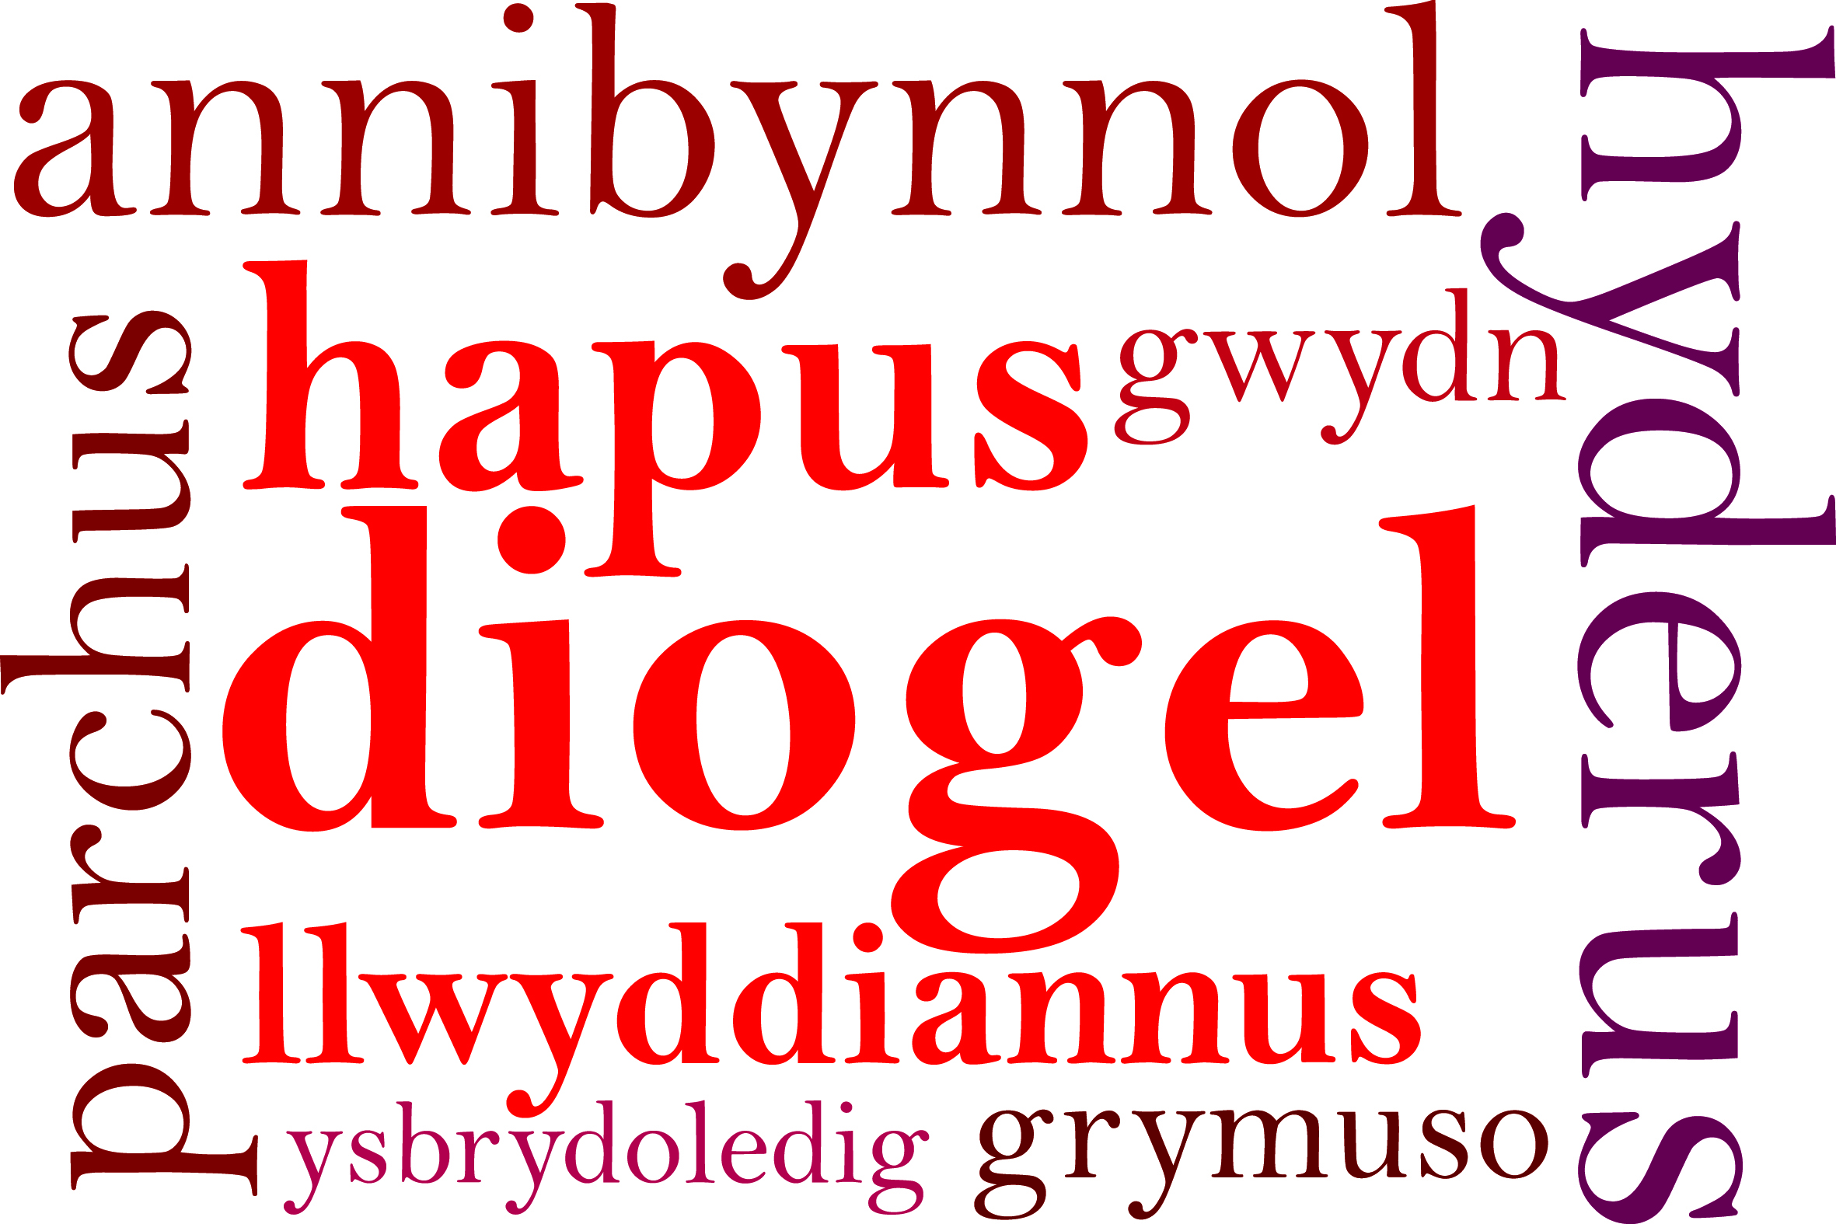

Dear Parents/Carers,

It was lovely meeting so many of you at parents’ evenings this week. This is a great opportunity to have time to speak to your child’s teacher and look at their books. Your feedback is very much appreciated. There is a list of the Spring term dates on the back of the newsletter.

School Improvement
Many of you may have seen that we have been awarded the ‘Green’ status again this year. This shows that Rumney Primary School continues to achieve the highest possible standards, provides appropriate and challenging opportunities and raises our children’s aspiration. Well done to the whole school community – great news!
We have been pleased with the response to improve attendance, well done pupils in Year 2 and Reception who have won the attendance trips so far this year. It would be super to see more classes having this reward for their attendance.
Safety
Many thanks to everyone who has been working with us to improve the safety around the beginning and end of the school day.
We are fortunate to have after school clubs for our children. We have appreciated your support in collecting the children at the end of the clubs. After half term if any parents/carers of children in Yr. 6 in would like their child to increase their independence in preparation for high school by allowing them to walk home on their own please can you put this in writing. School expects to know how the children leave school at the end of the day and at the end of the club attended.

Governors
We will shortly be asking parents if anyone is willing to join our governing body. If anyone is interested please come and meet with myself and find out what the role involves.

Chicks
Every year we support The Velindre charity through selling the Easter chicks. They will be on sale next half term for £1 each. The older children will be visiting the classes with the chicks.

FORPS
Friends of Rumney Primary School
We are very grateful to the members of FORPS for providing the help and support at events throughout the year and refreshments at the Christmas performances and Christmas Raffle afternoon. From the money raised we have been able to purchase new laptops as well as new trolleys to store and charge them. In our ever increasing digital world I.T. is a key to our children’s learning.
Thank you! Please keep giving your support and responding to the requests that may be about time not just money.

INSET Day
Half term starts early for pupils. Hopefully you are all aware that we have an INSET day on Friday 17th February. This means staff will be in for staff training and development, but not the children.
We return to school on Monday 27th February.

Dydd Gwyl Dewi
St. David’s Day Eisteddfod Celebrations will take place on Wednesday 1st March. The children are encouraged to come dressed in traditional costume or dressed in Welsh attire. Competitions will be going on over a number of days. I hope you will encourage your child to join in.
On Friday 3rd March you are invited into school to share an afternoon of entertainment, tea and Welsh cakes. The children in Year 2 – 6 will be performing; dancing, singing, reciting and playing their musical instruments.

SPRING TERM DATES

February 20th -24th - HALF TERM

Wednesday March 1st - Eisteddfod for pupils only

Friday March 3rd - Welsh Tea for all parents, pupils in Yr. 2 to Yr. 6 will be performing

Monday March 6th - Yr. 2 Enterprise Week
Yr. 6 Enterprise Week
Book Fair Week

Wednesday March 8th - 9:15 a.m. Class 8 Assembly
Yr. 5 educational visit to Cardiff Castle

Thursday March 9th - Yr. 2 visit St. Fagan’s

Friday March 17th - Yr. 5 ‘All Skilled Up’
(Cardiff City Football Club event)

Tuesday March 21st - Class 13 visit SWALEC Stadium (Cardiff Schools project)

Wednesday March 22nd - Class 14 visit SWALEC Stadium (Cardiff Schools project)

Friday March 24th - 9:15 a.m. Class 11 Assembly
Comic Relief Day – further details to follow
Yr. 5 ‘All Skilled Up’
(Cardiff City Football Club event)

Friday March 31st - Yr. 5 ‘All Skilled Up’
(Cardiff City Football Club event)

Monday April 3rd - Yr. 1 Enterprise Week
Yr. 6 Residential trip: Manor Adventure (return Wed)

Friday April 7th - FORPS Easter Raffle & KS2 Egg Competition
& Infant Easter bonnets
Yr. 5 ‘All Skilled Up’
(Cardiff City Football Club event)

END OF TERM

Monday April 24th - Start of the summer term.

Regards

Miss D E Williams

Headteacher

