**Activities to help develop fine motor skills (LNST)**

We normally divide motor skills into 3 areas: postural control, hand skills and handwriting skills. Try doing a few different activities from each group to help strengthen your handwriting skills.These activities are not progressive. If your chosen activities is too hard, see if you can make it easier - or if it is too easy, make it harder ☺

**Postural Control**

* Floor push-ups(you can make it easier by doing your push up against a wall)
* Bottom walking – sit on the floor with your legs straight out in front, raise your arms straight out in front at shoulder height and then try and walk across the room on your bottom by shifting your weight (going backwards may be easier). As you improve travel further and faster!
* Prone puppy lying – lie on stomach with hips flat on floor, raise upper chest and prop on shoulders. Maintain this position for increased lengths of time, e.g. whilst watching TV, playing, during story-time etc.
* Obstacle courses - include activities that involve moving through, between, over, wriggle under, slide along, climb up, etc.

Use table, chairs, benches, hoops, boxes, rugs, blankets, etc. Also try going backwards over the course.

* Action songs involving body parts e.g. ‘Head, shoulders, knees and toes.’ 'If you’re happy and you know it' (there are lots online) etc.
* Simon Says – use instructions that involve body parts e.g. raise your right arm, stand on one leg etc.
* Draw around body parts or whole body. Colour in according to what you are wearing. This can also be drawon a mirror or outside with chalk.
* Dressing up
* Drive a toy car over body parts while naming them, e.g. over foot, up leg, across tummy, under knee.
* Twister

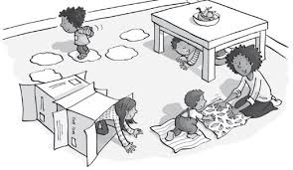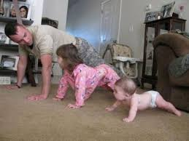

**Hand Skills**

* Threading beads or pasta etc. on to a lace or thread; the bigger the resources, the easier it is!
* Normal daily activities such as removing lids from containers and bottles, doing zips and buttons, turning on taps etc.
* Play with constructional toys that encourage making things with nuts, bolts, fixing wheels.
* Wind-up toys.
* Games that involve turning knobs and handles i.e. Pop-Up games.
* Model making out of clay or dough - try using simple tools such as shape cutters, rolling pins etc.
* Tearing paper into strips; use stiff paper or thin card first as it is easier to tear.
* Encourage a good scissor grip (use child friendly scissors) and practise cutting out – there are plenty of online activities
* Try cutting a simple shape with more than one change of direction, cutting along curved lines, cutting out circles, cutting more complicated shapes with straight and curved lines.
* Practice drawing around stencils or objects at home (a roll of sellotape) steadying with the assist hand, or have a go at shadow drawing.
* Using hole punches to make patterns in paper.
* Practice paper folding patterns, making patterns in paper with a single hole punch, lacing activities.

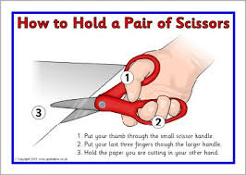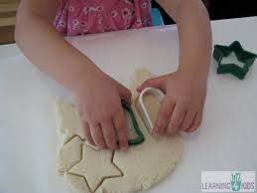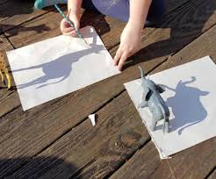

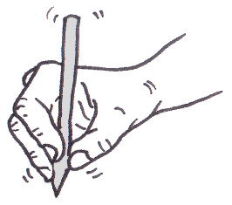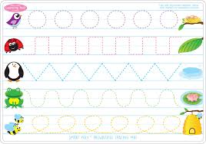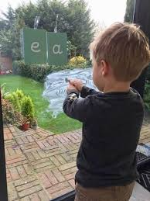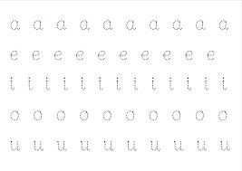

**Handwriting Skills**

* Remember to use your other hand to steady the paper during all writing, drawing and colouring tasks.
* Experiment with a range of pens and pencils to see which is easier.Try using chunky pens/pencils or pens with rubber grips or large barrels.
* Practise using an effective pencil grasp.
* Remember to work left to right.
* Working on vertical (an outside wall) or angled writing surfaces helps encourage the wrist to be slightly flexed and may make holding and controlling the pen easier.
* Remember to check pencil/pen pressure. Scribbling or doodling to music can help reduce tension and improve awareness of pressure.
* Teach letter formation in ‘families’ that have similar movement patterns, for example:
  + Long ladder e.g. *l i u t y*
  + Curly caterpillar e.g. *c a d g q o e s f*
  + One-armed robot e.g. *r n m h b k p*
  + Zig-zag e.g. *z x v w y k*
* Make sure that you practise those letters you find difficult – check that you are forming them the same way that you have learnt in school.
* Have a look for pre-writing worksheets online or in a book. It’s a good idea to keep practising a variety of patterns and shapes.
* Practice little and often!